# Website Accessibility Report

I used the WebAIM WAVE website accessibility checker to test my [EDET 735 final project website](https://mcgrievy.com/edet735). The WebAIM WAVE is a browser extension that can be [downloaded from WebAIM website](https://wave.webaim.org/extension/). When I initially designed the site, I tried to use accessible design practices (e.g., the use of semantic HTML elements, proper header structure, alt tags for images, and descriptive link text), but using WAVE to check it found a few issues that needed correcting. The image below summarizes the issues found. The two main accessibility items that need to be addressed are the six contrast errors and the six alerts. The other issues, such as the structural elements and ARIA elements are informational and do not necessarily indicate an issue that needs to be fixed.

**Figure 1**

Initial accessibility issues identified on the [EDET 735 final project website](https://mcgrievy.com/edet735).

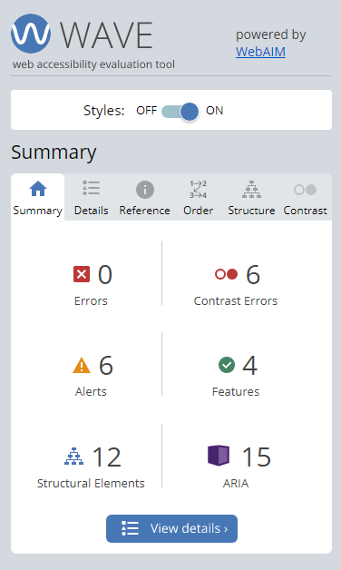

## Contrast Errors

The report lists two types of errors: general and contrast errors. Since the report listed zero general errors, I worked to fix the contrast errors first. The color I selected to indicate links did not have the proper contrast, with a ratio of 2.74:1. To pass the level AA Web Content Accessibility Guidelines (WCAG), text must have a contrast ratio of at least 4.5:1 for regular sized text. Larger text can have a contrast ratio of 3:1 and still pass (*Understanding Success Criterion 1.4.3: Contrast (Minimum) | WAI | W3C*, 2022). Because setting the contrast of the link color did not affect the functionality of the page, I corrected the contrast errors by using a link color (#2c596d) that met the higher, level AAA criteria with a ratio of 7:1.

## Alerts

The alerts that the WAVE tool flagged can be categorized as features that need to be reviewed, but not necessarily corrected. The first issue was that my page had a “redundant” link in the main navigation. The logo in the site’s header linked to the site homepage and the first item in my navigation menu was a “home” link. WAVE tagged that because two links that go to same place were rendered side by side. I removed the “home” link from the navigation to fix that issue, since the logo link would serve as the home link for screen reader navigation.

The other alerts flagged my links to PowerPoint, Word, and PDF documents as something that needed review. The WAVE documentation indicated that these types of files often have accessibility issues, and they should be checked. Because those files were designed with accessibility in mind and checked with Office and Adobe accessibility tools, no further action was needed.

Although it was not flagged by WAVE, when creating links, I tried to use descriptive text so that those using screen readers would know where the links went. Web design style guides I have used in the past have encouraged opening certain links (such as links to PDF files) in new tabs, but Web Content Accessibility Guidelines (WCAG) 2.0 state that opening links in new windows should be avoided where possible because it violates the principle of predictability in accessible design (*G200: Opening New Windows and Tabs from a Link Only When Necessary | Techniques for WCAG 2.0*, n.d.). Thus, all links on the web page open in the same window.

## Features

The next category listed features that supported accessibility. Items listed in this check included the presence of the “skip to content” link for screen readers, alt tags on images, and identifying the language of the page. This listing was informational, and no action was needed.

## Structural Elements and ARIA

Structural Elements and ARIA were two other informational categories that listed additional accessibility features. Structured elements on the page included all headers and sections such as the header, navigation, and footer. The WAVE tool created a visual representation of the structure and indicated that the page was structured properly.

ARIA stands for Accessible Rich Internet Applications and it is a tag system for assigning descriptions and attributes to controls, interactive elements on the page, menus, and page sections (*WebAIM: Introduction to ARIA - Accessible Rich Internet Applications*, 2020). The theme that I chose for the site included built-in ARIA features, and the WAVE tool indicated their presence and that there were no issues with the ARIA tags.

**Figure 2**

Accessibility report after fixes were applied on the [EDET 735 final project website](https://mcgrievy.com/edet735).

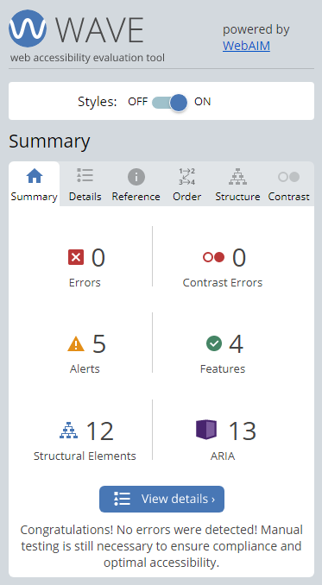

## Testing Accessibility

After addressing the issues flagged by the WAVE tool, I used two main methods to test the accessibility of my site for low vision users. The first was with the NVDA screen reader program. Because the site is relatively simple in structure and content, the screen reader worked extremely well, and the page was not difficult to navigate.

The second way I tested my site was to use the tab key to move through the content on the page. Tab order was predictable and properly structured. To further assist low vision users, and those with other visual impairments, I added an underline for all links and a box around the active link when using the tab key to move between links. The image below shows both underlined links and a box around the current active link:

**Figure 3**

Visual indicators for links

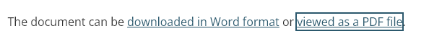

Proper tab order and visual indicators can also help low vision users who are not using a screen reader.

# References

*G200: Opening new windows and tabs from a link only when necessary | Techniques for WCAG 2.0*. (n.d.). Retrieved June 5, 2023, from https://www.w3.org/TR/WCAG20-TECHS/G200.html

*Understanding Success Criterion 1.4.3: Contrast (Minimum) | WAI | W3C*. (2022). https://www.w3.org/WAI/WCAG21/Understanding/contrast-minimum.html

*WebAIM: Introduction to ARIA - Accessible Rich Internet Applications*. (2020). https://webaim.org/techniques/aria/